**ExperimentNo. 1.5**

**Student Name:** Gaurav Kumar **UID:** 22MCC20177

**Branch:** MCA**–**CCD **Section/Group:** MCD-1/A

**Semester:** III **Date of Performance:** 15th Oct 23

**Subject Name:** Business Analytics **Subject Code:** 22CAH-703

1. **Aim/Overview of the practical:**
   1. Explain the term SQL and Oracle. State their use and benefits.
   2. Write the steps to install SQL.
2. **Code for practical: (a)**

* **SQL (Structured Query Language):** SQL is a domain-specific programming language used for managing and manipulating relational databases. It serves as a standard interface for interacting with databases, and it is used for tasks such as creating, querying, updating, and deleting data within a relational database management system (RDBMS). SQL provides a structured and consistent way to communicate with databases. Some of the core components of SQL include DDL, DML, DQL and DCL Commands.
* **Oracle** is a popular and widely used relational database management system (RDBMS) developed by Oracle Corporation. It is one of the most robust and feature-rich database systems available. Oracle databases are known for their scalability, reliability, and performance.

**Code for practical: (b)**

1. Open Terminal and run **“winget install --id=Oracle.MySQL -e”** command to install oracle MySQL.
2. After successfully downloading the install popup will appear.
3. Give MySQL Root password and port to run MySQL server.

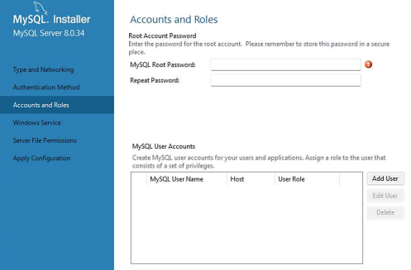

1. Now you can either use oracle MySQL from terminal as well as from the MySQL Workbench GUI application.
2. Use MySQL -u root -p command to run MySQL in terminal.
3. It will ask for Password enter your password to access MySQL.

